SAUDI HYPERMARKET
Retail Performance & Customer Insights Analytics
Python Data Analytics + Power BI Dashboard Project

Project Report
Analysis period: January 2024 – May 2026
Geographic scope: Saudi Arabia (KSA)
Currency: Saudi Riyal (SAR)
Executive Summary
This project presents an end-to-end retail analytics study of Saudi Hypermarket branch performance. The work combines Python-based data cleaning, preprocessing, feature engineering, exploratory data analysis (EDA), statistical relationships and business interpretation with an interactive Power BI dashboard.
The supplied notebook describes a dataset containing 3,000 records and 10 original columns, covering branch-level sales performance, transaction activity, product categories, payment methods and customer satisfaction. The analysis focuses on identifying revenue drivers, regional performance differences, store-size effects, payment behaviour and customer experience patterns.
- Total revenue is described in the notebook as approximately SAR 29 million across 35 branches and 12 regions.
- Transaction volume has the strongest reported relationship with total revenue, with a Pearson correlation of 0.87.
- Revenue per transaction has a moderate positive relationship with total revenue (0.55).
- Customer satisfaction has a weak relationship with total revenue (0.19), indicating that satisfaction and sales volume should be monitored as separate performance dimensions.
- Large branches are reported as the main revenue contributors, especially in major markets such as Riyadh and Central.
- Groceries and Fresh Produce are highlighted as major revenue categories, with Mada and Apple Pay contributing strongly to digital-payment revenue.
- The Power BI dashboard converts these findings into executive KPIs, trend visuals, category analysis, payment-channel analysis and interactive slicers.

2. Business Problem & Objectives
Operating hypermarkets across multiple Saudi regions requires clear visibility into sales trends, customer preferences and store operational efficiency. The project aims to support evidence-based decisions rather than relying only on manual reporting.

Objectives
- Clean and prepare branch-level retail data for reliable analysis.
- Identify regional and branch-size revenue patterns.
- Analyse transaction volume and revenue-per-transaction behaviour.
- Understand product-category and payment-method performance.
- Measure customer satisfaction and compare it with financial indicators.
- Create business-ready visualizations in Python.
- Build an interactive Power BI dashboard for management reporting.
- Translate analytical findings into actionable recommendations for inventory, marketing, store expansion and checkout operations.

3. Dataset Overview
Item | Details
Dataset | Saudi Hypermarket Branch Performance
Domain | Retail & Hypermarket Operations Analytics; Supply Chain & Financial Management
Source | Prime Levels Data Hub
Format | CSV
Rows | 3,000
Original columns | 10
Analysis period | January 2024 to May 2026
Geography | Saudi Arabia
Currency | SAR
Branches / regions | 35+ branches; 12 regions (as stated in the notebook)
Source URL recorded in the notebook: https://prime-levels.com/data-hub/saudi-hypermarket-branch-performance-2024-2026

3.1 Original Dataset Columns
Column | Business meaning
transaction_date | Date of the transaction record
branch_name | Hypermarket branch name
region | Administrative region in Saudi Arabia
branch_size | Large, Medium or Small store format
product_category | Main category of goods sold
total_revenue_sar | Total sales revenue in SAR
number_of_transactions | Number of transactions recorded
average_basket_sar | Average spend per transaction in SAR
payment_method | Customer payment method
customer_satisfaction_score | Customer satisfaction score on a 1.0–5.0 scale

4. Python Analytics Methodology
The notebook follows a structured analytics workflow:
- Problem definition and dataset selection.
- Initial data inspection and structural checks.
- Missing-value treatment and duplicate checks.
- Column standardization and unwanted-column removal.
- Outlier detection using the IQR method.
- Skewness checking and log transformation of revenue.
- Data-type conversion and date parsing.
- Feature engineering for revenue per transaction, revenue category, quarter, weekend flag, CSAT category and digital-payment indicator.
- Univariate, bivariate and multivariate EDA.
- Business interpretation after each visualization.
- Export of the cleaned dataset for downstream use.

4.1 Data Cleaning & Pre-processing
- Numerical missing values were filled using median imputation for revenue, transaction count, average basket and satisfaction score.
- Categorical missing values were filled using mode imputation for branch size, product category and payment method.
- Duplicate records were checked.
- Column names were standardized to lowercase with underscores.
- customer_satisfaction_score was renamed to sat_score for easier analysis.
- number_of_transactions.1 was removed when present.
- Revenue outliers were detected using 1.5 × IQR boundaries and filtered.
- A log-transformed revenue feature, total_revenue_sar_log, was created to address right-skewed revenue behaviour.
- number_of_transactions was converted to integer.
- transaction_date was converted to datetime.

4.2 Feature Engineering
Feature | Purpose
year | Year-based trend analysis
month | Monthly analysis
day_name | Day-of-week analysis
rev_per_trans | Revenue per transaction KPI
revenue_category | LOW / MEDIUM / HIGH revenue segmentation
quarter_period | Quarter-over-quarter analysis
weekends | Saudi weekend flag: Friday and Saturday
csat_category | Low / Medium / High satisfaction segmentation
digital_payment | Indicator for Mada, Credit Card and Apple Pay
total_revenue_sar_log | Log-transformed revenue for skewness handling

5. Exploratory Data Analysis & Key Findings

5.1 Revenue Distribution
The revenue histogram shows a right-skewed distribution. Most revenue observations are concentrated in lower-to-middle ranges, while a smaller number of high-value observations extend the upper tail.
Business meaning: the network has a broad baseline of regular activity with a smaller set of high-value periods or transactions.

5.2 Transaction Volume
The transaction-count boxplot indicates a stable central operating range with higher-volume outliers. The notebook interprets these as possible high-footfall or promotional periods rather than automatically treating them as data errors.

5.3 Customer Satisfaction
Customer satisfaction is concentrated toward higher ratings, with scores 4 and 5 forming the largest share. This indicates generally positive customer sentiment in the analysed records.

5.4 Regional Revenue Performance
- Riyadh and other primary urban markets are identified as top revenue contributors.
- A substantial share of enterprise revenue is concentrated in the top two regional markets.
- Lower-performing regions provide opportunities for localized promotions, product-mix adjustments and targeted inventory planning.
- Regional sales patterns can guide supply-chain and fulfilment-resource allocation.

5.5 Revenue and Transaction Correlation
The notebook reports a strong positive Pearson correlation of 0.87 between total_revenue_sar and number_of_transactions. This supports the conclusion that transaction volume/footfall is a major revenue driver.
Revenue per transaction has a moderate positive correlation of 0.55 with total revenue, while customer satisfaction has a weak correlation of 0.19.

5.6 Branch Size Performance
- Large branches generate the highest total revenue contribution, followed by Medium and Small branches.
- Large formats dominate high-volume markets such as Riyadh and Central in the notebook's analysis.
- Medium branches provide a stable contribution across locations.
- Small branches in lower-footfall areas show potential for product-mix and local-demand optimization.

5.7 Product Category & Payment Method
- Groceries and Fresh Produce are highlighted as major revenue categories.
- Mada and Apple Pay are identified as strong digital-payment channels for high-demand categories.
- Cash remains relevant for lower-basket or everyday purchases.
- Credit-card payments contribute to steady revenue, particularly for higher-value non-perishable purchases.
- Fast digital POS lanes can help support peak-period checkout flow.

5.8 Quarterly & Digital-Payment Behaviour
The quarterly analysis compares revenue by digital-payment usage across Large, Medium and Small branches. The notebook highlights higher revenue contribution from digital transactions, particularly in Large and Medium formats, and notes seasonal differences between quarter periods.

POWER PI DASHBOARD
Executive Performance
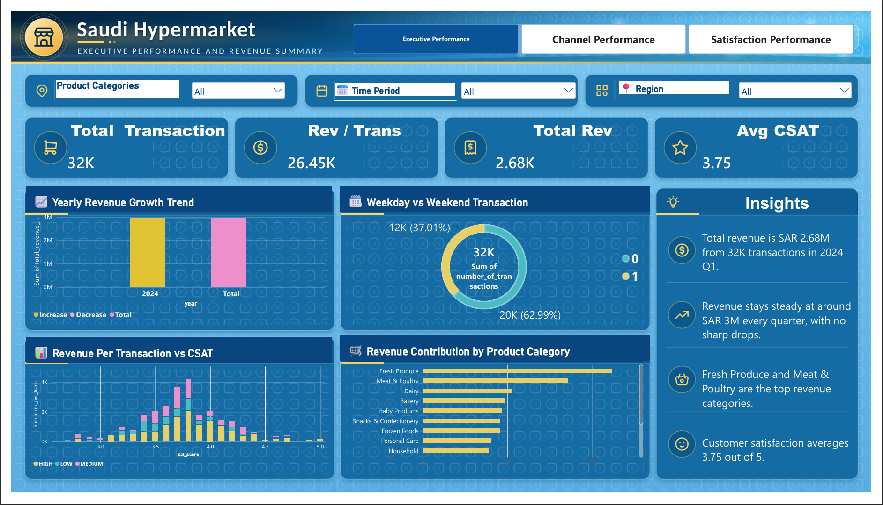

Overview
The Executive Performance page provides C-suite leadership with macro health metrics, revenue velocity, basket size, and overall satisfaction indicators.

Key Visual
- KPI Cards:
  - Total Transactions: 32K transactions (baseline 2024 Q1 filter context).
  - Rev / Trans: 26.45K SAR.
  - Total Revenue: 2.68M SAR (2024 Q1 baseline).
  - Avg CSAT: 3.75 out of 5.0.
- Yearly Revenue Growth Trend (Waterfall Chart): Displays steady revenue accumulation across years with clear increase/total indicators without major drop-offs.
- Weekday vs Weekend Transaction (Donut Chart):
  - Weekday (0): 20K transactions (62.99% share).
  - Weekend (1): 12K transactions (37.01% share).
  - Takeaway: Strong weekday footfall driven by daily routine grocery shopping.
- Revenue Per Transaction vs CSAT (Column Chart): Evaluates basket size against customer satisfaction scores grouped by CSAT tiers (HIGH, MEDIUM, LOW).
- Revenue Contribution by Product Category (Horizontal Bar Chart): Top revenue generators: Fresh Produce (~16.25% share) and Meat & Poultry (~9.84% share), followed by Dairy, Bakery, and Electronics.
- Side Panel Executive Insights:
  - Total revenue reached SAR 2.68M from 32K transactions in 2024 Q1.
  - Revenue stays steady at ~SAR 3M every quarter with no sharp drops.
  - Fresh Produce and Meat & Poultry are top revenue drivers.
  - Customer satisfaction averages 3.75 out of 5.

Channel Performance
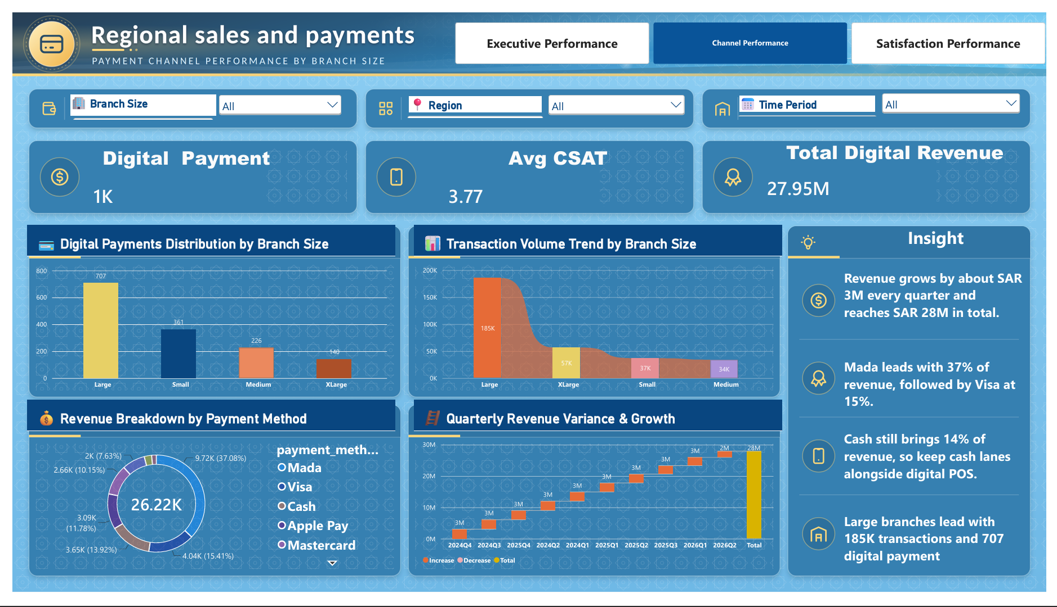

Overview
The Channel Performance view evaluates payment transformation, digital adoption, store scale efficiency, and quarterly revenue stability.

Key Visual
- KPI Cards:
  - Digital Payment Count: 1K transactions logged in digital modes.
  - Avg CSAT: 3.77 satisfaction score.
  - Total Digital Revenue: 27.95M SAR total cumulative revenue.
- Digital Payments Distribution by Branch Size (Bar Chart):
  - Large Branches: 707 digital transactions (leads the retail chain).
  - Small Branches: 361 transactions.
  - Medium Branches: 226 transactions.

  - XLarge Branches: 140 transactions.
- Transaction Volume Trend by Branch Size (Area/Area-Stacked Chart): Large stores process over 185K transactions, demonstrating massive volume handling compared to XLarge (57K), Small (37K), and Medium (34K).
- Revenue Breakdown by Payment Method (Donut Chart):
  - Mada: 37.08% share (9.72K records / 10.41M SAR).
  - Visa: 15.41% share (4.04K records / 4.40M SAR).
  - Cash: 13.92% share (3.65K records / 3.78M SAR).
  - Apple Pay: 11.78% share (3.09K records / 3.24M SAR).
  - Mastercard: 10.15% share (2.66K records / 2.87M SAR).
  - STC Pay & BNPL (Tabby/Tamara): ~11.66% combined.
- Quarterly Revenue Variance & Growth (Waterfall Chart): Demonstrates highly consistent quarterly revenue addition of ~SAR 3M per quarter, accumulating to SAR 27.95M.
- Side Panel Channel Insights:
  - Revenue grows by ~SAR 3M every quarter, reaching SAR 28M total.
  - Mada leads with 37% of revenue, followed by Visa at 15%.
  - Cash brings 14% of revenue — keep cash lanes alongside digital POS.
Large branches lead with 185K transactions and 707 digital payment logs.

Satisfaction Performance
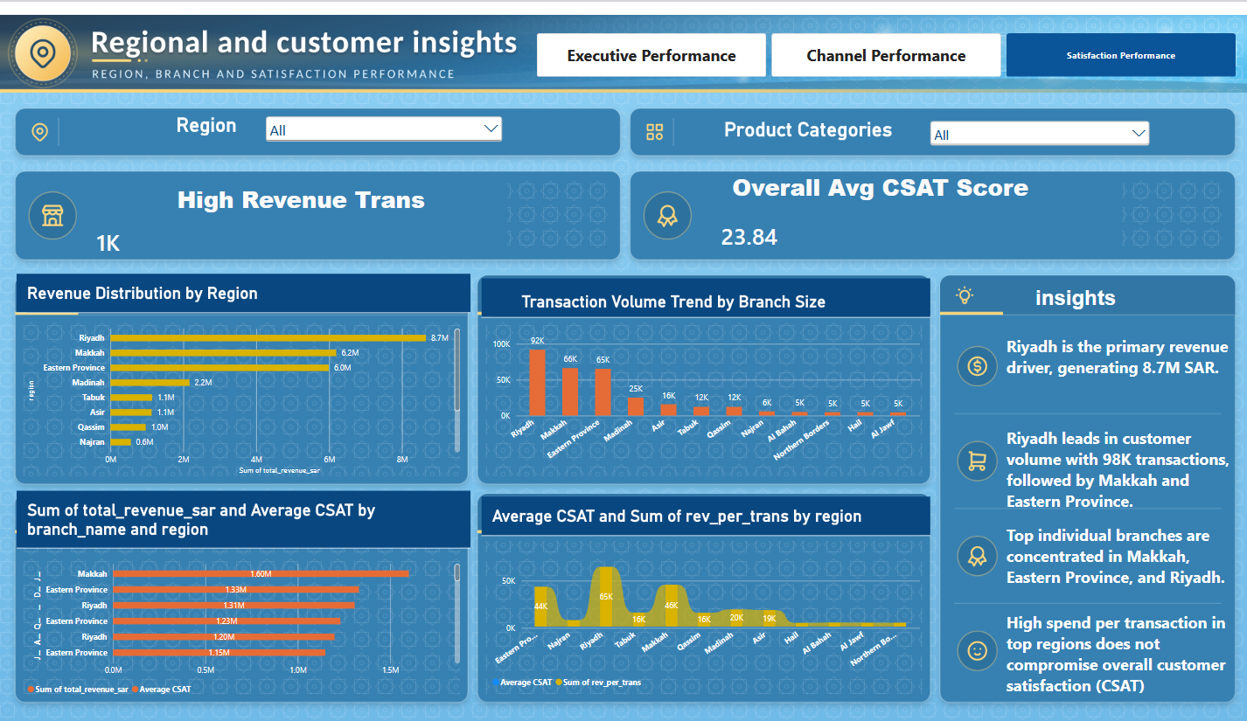

Overview
The Satisfaction Performance page provides operational deep-dives into regional revenue share, branch-level satisfaction, and regional ticket sizes.

Key Visual
- KPI Cards:
  - High Revenue Transactions: 1K high-value transactions.
  - Overall Avg CSAT Score: 23.84 aggregate benchmark index (3.78 overall mean CSAT across regions).
- Revenue Distribution by Region (Horizontal Bar Chart):
  - Riyadh: 8.7M SAR (Primary revenue driver).
  - Makkah: 6.2M SAR.
  - Eastern Province: 6.0M SAR.
  - Madinah: 2.2M SAR.
  - Tabuk & Asir: 1.1M SAR each.
  - Qassim & Najran: 1.0M – 0.6M SAR.
- Transaction Volume Trend by Branch Size across Regions (Column Chart): Highlights transaction concentration in primary provinces: Riyadh (92K transactions), Makkah (66K transactions), and Eastern Province (65K transactions).
- Sum of Total Revenue SAR and Average CSAT by Branch Name & Region (Combo Bar/Line Chart): Identifies top branches in Makkah (1.60M SAR), Eastern Province (1.33M SAR), and Riyadh (1.31M SAR) while tracking their CSAT scores.
- Average CSAT and Sum of Rev Per Trans by Region (Area Chart): Analyzes customer sentiment against average transaction values across Eastern Province, Najran, Riyadh, Tabuk, Makkah, and other regions.

7. Business Recommendations
- Prioritize high-volume regions such as Riyadh and other leading markets for inventory availability and fulfilment capacity.
- Use transaction volume as a primary operational KPI because the notebook reports the strongest correlation between transaction count and revenue.
- Protect and expand high-performing Large-branch formats where demand and location economics support additional investment.
- Use localized promotions and product-mix adjustments in lower-performing regions instead of applying the same strategy across all markets.
- Strengthen digital POS capacity and fast checkout lanes, particularly during high-volume periods.
- Monitor high-revenue product categories such as Groceries and Fresh Produce closely to reduce stock-out risk.
- Track revenue per transaction alongside transaction count to distinguish traffic growth from basket-value growth.
- Maintain CSAT as a separate customer-experience KPI because its reported correlation with revenue is weak.
- Use quarterly trends to plan seasonal inventory, staffing and promotional activity.
- Continue using the Power BI dashboard as a management reporting layer for interactive filtering and decision support.

8. Tools & Technologies Used
Tool / Technology | Usage
Python | Data cleaning, preprocessing, feature engineering and analysis
Pandas | Data loading, transformation, grouping and feature creation
NumPy | Numerical calculations and log transformation
Matplotlib | Data visualization
Seaborn | Statistical and business visualizations
Power BI | Interactive dashboard and executive reporting
CSV | Source / cleaned analytical dataset format

9. Project Outcome
The project successfully combines Python analytics with Power BI reporting to create a practical retail decision-support workflow. The analysis identifies transaction volume, regional concentration, branch size, product category and payment behaviour as important dimensions of hypermarket performance. The dashboard then packages these findings into an interactive management view.

10. Conclusion
The Saudi Hypermarket Retail Performance & Customer Insights Analytics project demonstrates how raw retail records can be transformed into actionable business intelligence. Python provides the analytical foundation through cleaning, feature engineering, EDA and statistical interpretation, while Power BI provides an executive-friendly interface for monitoring revenue, transactions, customer satisfaction, branch size and payment-channel performance.
Overall, the analysis supports a data-driven strategy focused on increasing transaction volume, protecting high-performing markets, optimizing store formats and product availability, improving digital checkout capability and continuously monitoring customer experience.

